Main activity
package srm.it.myapplication
import android.content.Intent
import androidx.appcompat.app.AppCompatActivity
import android.os.Bundle
import android.widget.Toast
import kotlinx.android.synthetic.main.activity_main.*
import kotlinx.android.synthetic.main.fragment_second.*
class MainActivity : AppCompatActivity() {
override fun onCreate(savedInstanceState: Bundle?) {
Toast.makeText(this,"on create",Toast.LENGTH_SHORT).show()
super.onCreate(savedInstanceState)
setContentView(R.layout.activity_main)
button3.setOnClickListener {
var name=box1.text.toString()
var newpage=Intent(this,seconds::class.java)
newpage.putExtra("Name",name)
startActivity(newpage)
}
}
}
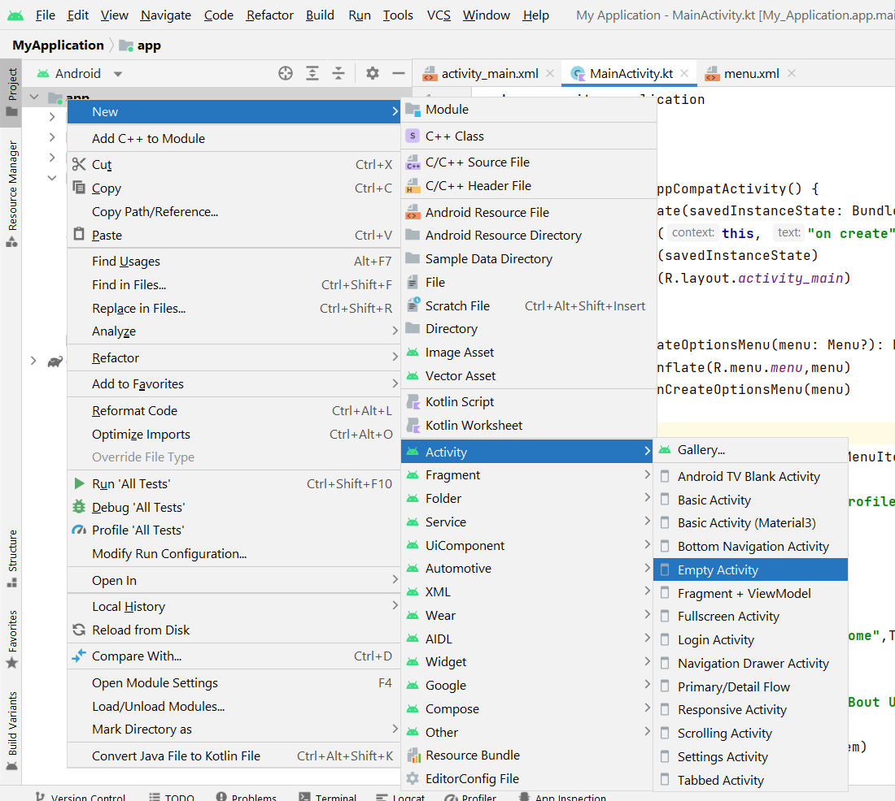
- Give name as (seconds)
seconds
package srm.it.myapplication
import androidx.appcompat.app.AppCompatActivity
import android.os.Bundle
import kotlinx.android.synthetic.main.activity_main.*
import kotlinx.android.synthetic.main.activity_seconds.*
class seconds : AppCompatActivity() {
override fun onCreate(savedInstanceState: Bundle?) {
super.onCreate(savedInstanceState)
setContentView(R.layout.activity_seconds)
var data=intent.getStringExtra("Name")
label.text="welcome $data"}}

